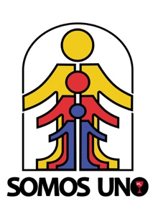
Obra Hispana People-to-People Pilgrimage
Guatemala
May 19-26, 2020

Registration Form

GENERAL INFORMATION

Name _______________________________________________________________DOB
(As it appears on your passport – Please attach a copy of the Passport Photo Page and Medication List w/dosage)

Address: ___________________________________________________ City ______________________________

State: __________________ Zip _________________ Phone: _____________________________ Gender _____

2nd phone number: ________________________ Email address _________________________________________

Passport number: __________________________________ Expiration Date: ____________________________

Emergency Contact Person _______________________________________________________________________

Phone(s): __________________________________________________ Relationship: ______________________

Region: ____________________________ Local Church: ______________________________________________

Special Dietary Restrictions: ______________________________________________________________________

Allergies: _____________________________________________________________________________________

RELEASE AND WAIVER OF LIABILITY AND EMERGENCY MEDICAL CARE AUTHORIZATION

I hereby state that I will not hold Global Ministries, the Christian Church (Disciples of Christ), the United Church of Christ, or international partners legally responsible for any accident, sickness, injury, or loss that may occur during this pilgrimage. I hereby state that I am in good health and have all medications necessary to treat any allergic or chronic conditions, and I am able to administer such medications without assistance. If at any time during the pilgrimage I need emergency medical care and am not able to give consent because of my physical or mental condition, I authorize emergency medical care decisions to be made on my behalf.

Signature: _____________________________________________ Date: __________________
Authorize emergency treatment and legal disclaimer

PAYMENT INFORMATION:

You can pay in two ways: Online at https://donate.globalministries.org/people-to-people-pilgrimage (write Pilgrimage to El Salvador 2020 on the Designation Information section) or mail a check.

Check Payable: Global Ministries
Mail to: People to People Pilgrimage Program (Attn: Lorna Hernandez)
PO Box 1986, Indianapolis, IN 46206-1986
For information contact the Central Pastoral Office for Hispanic Ministries somosuno@cpohm.disciples.org, (317) 713-2584

